

EMAIL SPAM CLASSIFICATION

Submitted by:

Mitesh verma

**ACKNOWLEDGMENT**

I would like to acknowledge Mr. Shwetank Mishra (FlipRobo) for his vital

cooperation and help in ensuring the successful completion of my assignment.

He deserves the utmost credit for the assignment’s outcome.

Finally, I would want to convey my sincere thanks Datatrained Academy

and their guidance without them, the task would not have been

accomplished.

The website that I referred are:

<https://learning.datatrained.com>

[https://www.w3schools.com](https://www.geeksforgeeks.org)

[https://medium.com/coders-camp](https://www.geeksforgeeks.org)

[https://github.com](https://www.geeksforgeeks.org)

<https://www.geeksforgeeks.org>

[https://www.javatpoint.com/nlp](https://www.geeksforgeeks.org)

[https://www.educative.io/answers/preprocessing-steps-in-natural-language-processing-nlp](https://www.geeksforgeeks.org)

[https://www.youtube.com/watch?v=5ctbvkAMQO4](https://www.geeksforgeeks.org)

[https://www.youtube.com/watch?v=X2vAabgKiuM](https://www.geeksforgeeks.org)

**INTRODUCTION**

* Business Problem Framing

Spam Filtering

Spam Detector is used to detect unwanted, malicious and virus infected texts and helps to separate them from the nonspam texts. It uses a binary type of classification containing the labels such as ‘ham’ (nonspam) and spam. Application of this can be seen in Google Mail (GMAIL) where it segregates the spam emails in order to prevent them from getting into the user’s inbox.

The SMS Spam Collection is a set of SMS tagged messages that have been collected for SMS Spam research. It contains one set of SMS messages in English of 5,574 messages, tagged according to ham (legitimate) or spam.

* Conceptual Background of the Domain Problem

The main goal of the assignment is to show how you could design a spam filtering system from scratch.

* Review of Literature

The files contain one message per line. Each line is composed by two columns:

* v1 contains the label (ham or spam)
* v2 contains the raw text.
* Motivation for the Problem Undertaken

Implementing spam filtering is extremely important for any organization. Not only does spam filtering help keep garbage out of email inboxes, it helps with the quality of life of business emails because they run smoothly and are only used for their desired purpose. Spam filtering is essentially an anti-malware tool, as many attacks through email are trying to trick users to click on a malicious attachment, asking them to supply their credentials, and much more.

**Analytical Problem Framing**

* Mathematical/ Analytical Modeling of the Problem
* **Information of the dataset:**

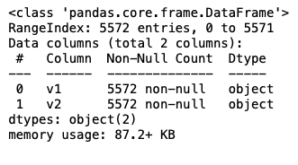

* **Description of the dataset:**

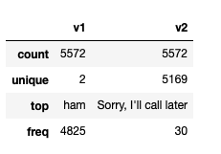

* Data Sources and their formats
* A collection of 5573 rows of SMS spam messages was manually extracted from the Grumbletext Web site. This is a UK forum in which cell phone users make public claims about SMS spam messages, most of them without reporting the very spam message received. The identification of the text of spam messages in the claims is a very hard and time-consuming task, and it involves carefully scanning hundreds of web pages.
* A subset of 3,375 SMS randomly chosen ham messages of the NUS SMS Corpus (NSC), which is a dataset of about 10,000 legitimate messages collected for research at the Department of Computer Science at the National University of Singapore. The messages largely originate from Singaporeans and mostly from students attending the University. These messages were collected from volunteers who were made aware that their contributions were going to be made publicly available.
* Data Preprocessing Done

In data pre-processing, I have done the various steps to clean the dataset, as the dataset contains the comment that are in object datatype, which cannot be read by the model, so before giving the features to the model I had to convert that object datatype to meaningful data and that can be understand by the model, so for this I have used the NLP (Natural Processing Language).

“Natural language processing (NLP) refers to the branch of computer science and more specifically, the branch of artificial intelligence (AI) concerned with giving computers the ability to understand text and spoken words in much the same way human beings can.”

* Data Inputs- Logic- Output Relationships

Used TF-IDF Vectorizer to encode the comments section.

“TfidfVectorizer is the base building block of many NLP pipelines. It is a simple technique to vectorize text documents i.e. transform sentences into arrays of numbers and use them in subsequent tasks.”

* Hardware and Software Requirements and Tools Used

Anaconda-navigator

jupyter notebook

matplotlib-inline==0.1.6

numpy==1.23.2

packaging==21.3

pickleshare==0.7.5

platformdirs==2.5.2

prompt-toolkit==3.0.30

pyparsing==3.0.9

python-dateutil==2.8.2

scikit-learn==1.1.2

scipy==1.9.0

sklearn==0.05

NLP==GPT3

Naive-Bayes

**Model/s Development and Evaluation**

* Identification of possible problem-solving approaches (methods)
* **EDA**
* **Description**
* **Visualization**
* **Data cleaning**
* **Data Pre-processing (NLP)**
* **Word Cloud**
* **Encoding**
* **Model Building**
* **Select the best model**
* **Cross-Validation**
* **Hyperparameter tuning**

* Testing of Identified Approaches (Algorithms)

Algorithms used for the training and testing:

* AdaBoost Classifier
* GradientBoosting Classifier
* KNeighbors Classifier
* RandomForest Classifier
* Logistic Regression
* Naive Bayes (GaussianNB)
* Run and Evaluate selected models
* AdaBoost Classifier

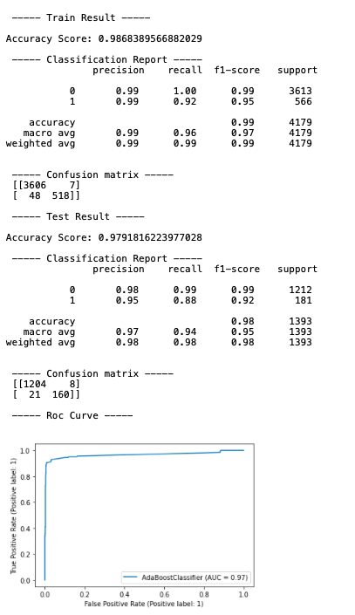

* GradientBoosting Classifier

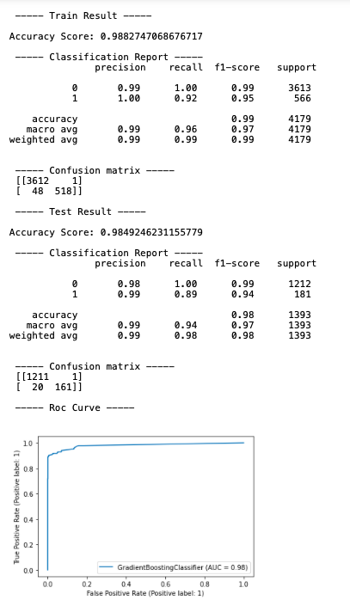

* KNeighbors Classifier

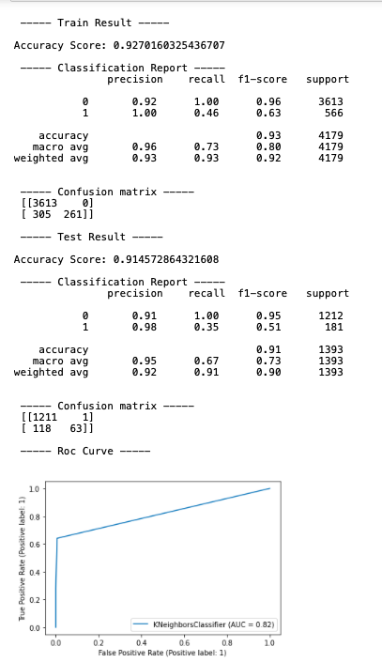

* RandomForest Classifier



* Logistic Regression

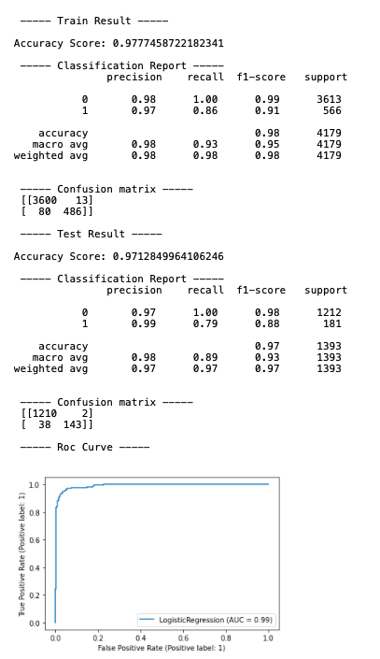

* Naive Bayes (GaussianNB)

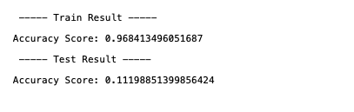

* Interpretation of the Results

RandomForest Classifier is giving the best result as compared to others.

**CONCLUSION**

* Learning Outcomes of the Study in respect of Data Science

Apply computing theory, languages, and algorithms, as well as mathematical and statistical models, and the principles of optimization to appropriately formulate and use data analyses. Formulate and use appropriate models of data analysis to solve hidden solutions to business-related challenges. Perform well in a group.